Geological Views and Diagrams
Folds

Geological Views:
Geology involves studying what lies underground. Unfortunately, we usually can only see the surface which is covered by vegetation, water and buildings.

Block Diagrams:
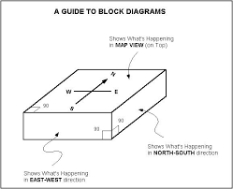
Geologists often put together information they have from different views (map view with cross-sections) into one diagram called a block diagram
This helps look for patterns and fill in possible gaps in information.
Strike and Dip Symbols
On the surface map view, strike-dip symbols give more information.
Strike symbol is long and drawn parallel to the structure to indicate direction
Dip symbol is short and perpendicular to the Strike, it indicates the direction in which a structure in plunging (going down)
Folds:

Folding occurs when the rock or other material is compressed.
Diagram:

Fracture or Faults may occur if folding continues to the point the rock breaks.
Because this process causes material to push upwards it leads to a phenomenon called
crustal thickening

Types of folds:

Synclines: it looks like a smile with the youngest rock on the middle
Diagram:

Syncline Block Diagram:
- Symmetry on both sides of fold

- Dip symbol point inwards

- The youngest rock in the middle

Anticline folds: it looks like a frown with the youngest rock on the top, oldest in the middle
Diagram:

Anticline Block Diagram:
- Symmetry on both sides of fold

- Dip symbol point outwards

- The older rock in the middle

Plunging Folds:
An non-plunging syncline or anticline will appear as straight lines on a map view, whereas a plunging syncline or anticline with appear u-shaped

Non-plunging: | Plunging:

Special Folds:
Basin: a syncline that dips in from all sides | Dome: an anticline that dips out from all sides

