Ore Bodies and Mineral Deposits Continued

Sedimentary Deposits

When shallow seas evaporate, they leave behind layers of minerals, typically gypsum or ______________.
Where coral reefs once existed, you can often find deposits of calcite or limestone. This is because all of these things contain
_____________________ as their main ingredient.
A special type of sedimentary deposit, often found in streams, is called a _________________...
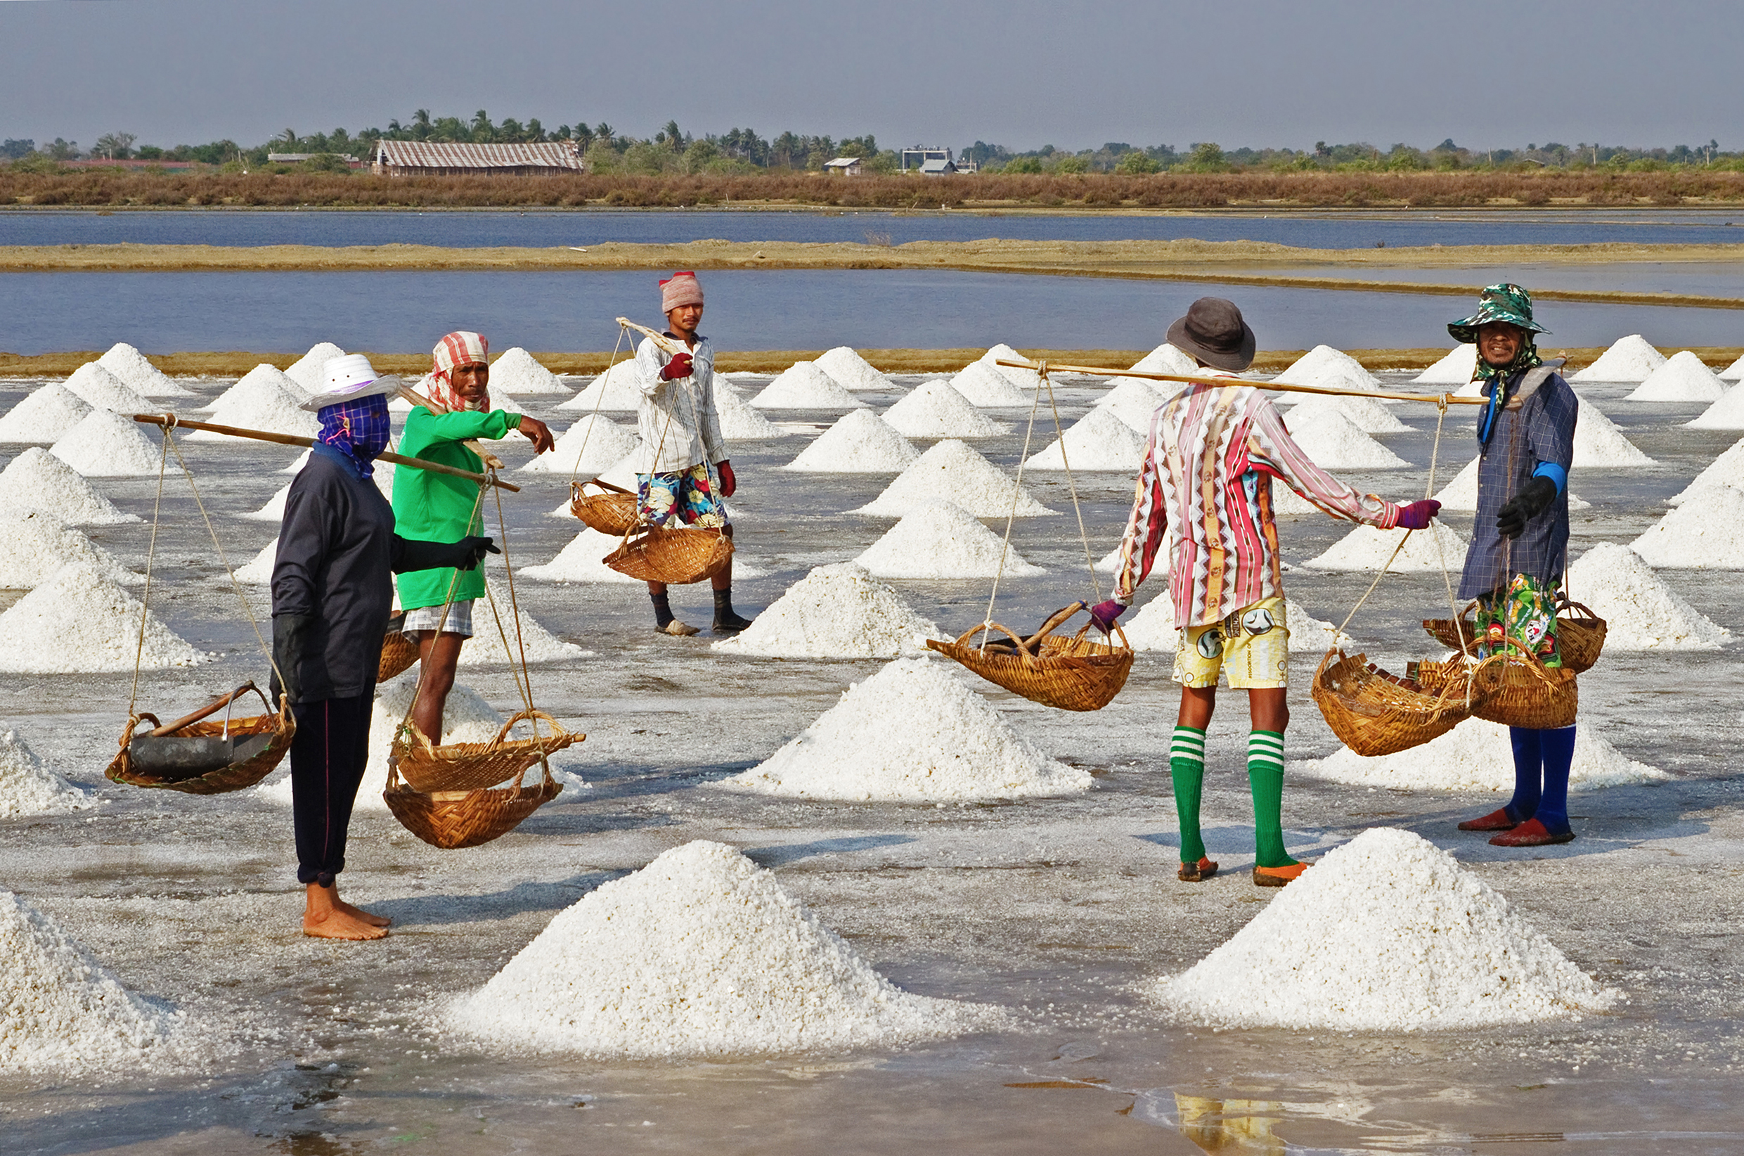

Placer Deposits
The most common mineral to be deposited by placers is gold.
Gold is very ____________, so it’s easily weathered and eroded by streams.
Gold is very dense (has a high ____________________), so it gets
deposited where the water ______________________________.
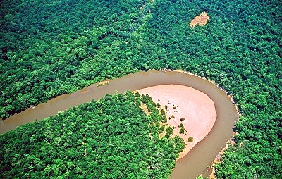

Metamorphic Deposits

In geology, the term ______________________ refers to the
application of _________________ and _______________________.
Together, these act to recrystalize “_________________” material
into “___________________” material.
Examples:
Coal + low heat/pressure = _____________________
Graphite + high heat/pressure = _________________

