Important Index Fossils

Index Fossils

A “guide” fossil or “index fossil” is a sort of marker that’s used to date sedimentary rock. The qualities of a good guide fossil are:
- Must be __________________ and easily recognized.
- Can only have existed for a _______________________________.
- Must be geographically _____________________.

Tree of Life
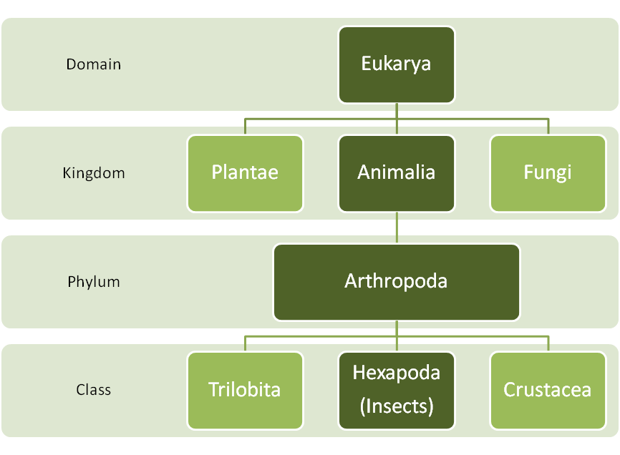

Important Index Fossils

Trilobites (#20) Phylum: Arthropoda
- Some of the earliest invertebrate creatures and index fossils for the Paleozoic Era. Most common during the Cambrian and Ordovician periods.
- Are now extinct.
Brachiopods (#11 and #15) Phylum: Brachiopoda
- Have wing-like or hooked shells that are not symmetrical.
- Very common in the Paleozoic Era.
Ammonites (#9) Phylum: Molusca
- Related to squid and octopus. They have shells that are coiled and ornate.
- Abundant during the Mesozoic Era and became extinct with the dinosaurs.
Bivalves (#1) Phylum: Molusca
- Animals with symmetrical, hinged shells. For example: clams and scallops.
Gastropods (#2) Phylum: Molusca
- Animals with coiled, spiral shells. For example: snails.
Echinoderms (#14) Phylum: Echinodermata
- Marine animals that display five-fold radial symmetry. Much like starfish.
Verbrates Phylum: Chordata
- A large sub-phylum of animals containing backbones or cartilage. For example: dinosaurs, mammals, fish, birds, reptiles, etc.
- The most common guide fossil for this group is the shark tooth (#4).
Stromatolites
- Precambrian mats of algae that trap mud and other sediments.
- These are the oldest known plants (up to 3.5 billion years old!)

