Physics 11
Unit 3 – 2D Kinematics
Section 3.1: Working with Vectors

Remember the rules for adding vectors?
- We can put them in any __________________________.
- Each time we add a new vector, we _______________________________________________________________________.
- The answer (__________________) goes from ________________________________________.
To subtract vectors, we __________________________________________.
To multiply a vector by a scalar, we multiply its ______________________ and keep its _________________________ the same.
Examples:
3 m Down – 4 m Left 2 m/s West + (1 m/s North) x 3

What if, rather than drawing the resultants (like we just did), I wanted you to write them in words?
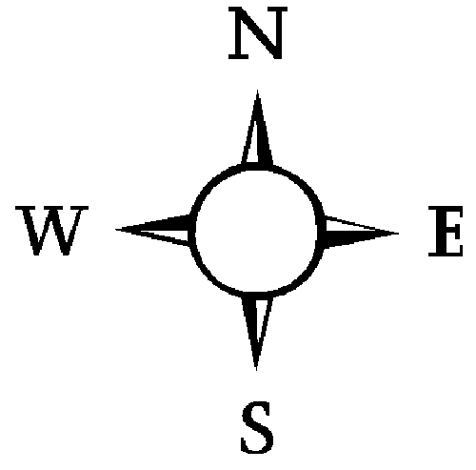
Examples: Describe the magnitude and direction of the following vectors.
15º
12 m/s²
3 m
50º

Now let’s put it all together (and review trigonometry).

Examples: Write the resultant.
3 m/s up + 4 m/s right

5 m west – 2x(2 m north)

