Name: ________________________________ Physics 11
Worksheet 5.5
Hooke’s Law

- One end of an elastic cord is glued to a wall. If the elastic band has a spring constant of 9 N/m and you pull on the free end such that it is stretched by 15 cm, what is the magnitude of the elastic force that the band exerts on you?
- A bungee jumper is hanging from her bungee cord after a jump (her acceleration is zero). If the bungee cord has a spring constant of 42 N/m and the jumper has a mass of 65 kg, how far is the cord being stretched? Start by drawing an FBD for the hanging jumper.
- In a pinball machine, a metal spring is used to accelerate the ball horizontally from rest. If the spring is pulled back 11 cm and, at the instant it is released, accelerates a 100 g ball at 22 m/s², what is the spring constant?
- A student loads a rock into the slingshot shown below and stretches the elastics 0.5 m. He holds the rock steady for a few seconds. If the slingshot elastics have a spring constant of 50 N/m, what force is the student applying to the rock as he holds it there? Start by drawing an FBD for the rock.
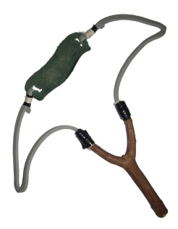

Answers: 1) 1.35 N 2) 15.2 m 3) 20 N/m 4) 50 N

