The Signature of the Stars Name:

**Part 1: Elements and their colours - the Flame Test**

The electrons in an atom occupy different energy levels. Remember your Bohr models?

Draw a Bohr model of:

Sodium Aluminum Lithium

When all of the electrons are at the lowest possible energy level they are said to be in the

Electrons do not always stay in the ground state. Sometimes they can be promoted to a higher-energy electron shell.

When an atom is in the flame, an electron in the outer shell of that atom receives energy from the flame and jumps up to a higher-energy shell position. When an electron is in a higher-energy shell it is said to be in an

Electrons in excited states do not usually stay in them for very long. When electrons lose their energy they do so by emitting a

Photons are particles with energy but no mass. Their energy is directly proportional to the frequency of the light. The photons emitted precisely match the quantum energy difference between the excited state and the ground state.

What is a flame test?

Watch the flame test demonstration. Write down every element tested and the colour of the light emitted.

Why do different elements have different colour flames?

**Part 2: Elements and their absorption spectra**

Rainbows reveal that white light is a combination of all the colours. In 1666, Isaac Newton showed that white light could be separated into its component colours using glass prisms. Soon scientists were using this new tool to analyze the light coming from several different light sources. Some scientists looked at hot objects and gases; others looked at the stars and planets. They all made observations and detected patterns, but it took about 250 years for scientists to understand the connections.

The spectrum below is in black and white. Use colours to shade in the proper spectrum

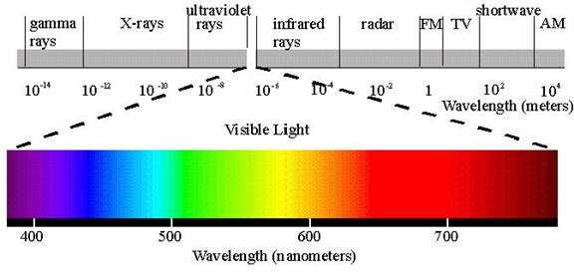



Every Element Has a Unique Signature.

Every element emits a unique range of colours called an emission spectrum. A similar spectrum is produced when light shines through a gas; however, in this case certain colours, or wavelengths, are absorbed by the gas.

An absorption spectrum is the pattern of colours and dark lines that is produced when light shines through a gas and the gas absorbs certain wavelengths.

The lines indicate the wavelengths of light that are missing from the light after passing through the sample. The weight (thickness) of the lines indicates the amount of light absorbed at that wavelength. The heavier (or thicker) the line, the more light is absorbed.

**Question**

The absorption spectra to the right came from two different stars. Identify the elements present in the star that produced the

Top spectrum:

Bottom spectrum:

The Light from Stars Contains Information.

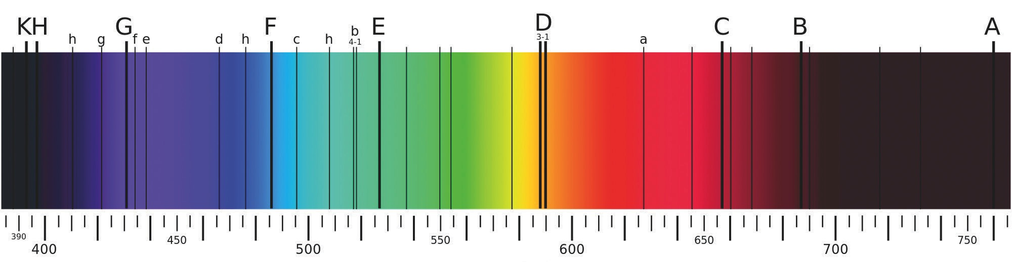The core of a star is very hot (~15 × 106 K), and very hot objects glow. The light produced by a star’s core contains all the colours in the spectrum. Astronomers can learn many things about a star’s motion, temperature, and composition by analyzing the starlight that reaches Earth. A spectroscope is an instrument that separates light into its spectrum. One of the earliest uses of the spectroscope was to analyze light coming from astronomical objects. The light directed from a telescope through a spectroscope produces an image called a **spectrograph**. Below is a spectrograph of our Sun. Lines A and B are due to terrestrial oxygen and are not due to the Sun.

**Wavelength (nm)**

1. What do the dark lines in our sun's spectrograph indicate?

2. Use the simplified absorption spectra on the next page to identify which elements are in the Sun, that is, which element each letter in the spectrum above represents (except for A and B).

3. In Its core, our Sun uses hydrogen as its fuel and produces helium. It is not massive enough to fuse any heavier elements together. Where do the elements in the outer layers of our Sun come from?

4. If a star’s absorption spectrum showed it contained only hydrogen and helium and no other elements, do you think it would be a very young star or a very old star? Explain.

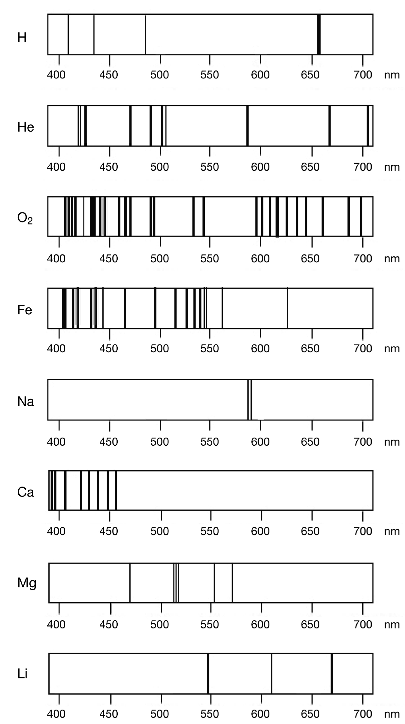

Simplified absorption Spectra