Conservation of Energy at the Skate Park
Name:

PhET Energy Skate Park Simulation: https://phet.colorado.edu/en/simulation/energy-skate-park

Energy Changes in the Skate Park System: Potential, Kinetic, and Total

Directions.
- Use the regular PhET skateboarder
- Make sure the Friction is set for zero and you are on Earth
- Open the “bar graph” window

1. Put the skater on the top of the ramp and let him go. Pause him at different positions and draw the bar graph when the skater is:

At the top of the ramp Halfway down the ramp At the bottom

What do you notice about the relationship between the three bars on your graph: potential energy, kinetic energy, and total energy:

Now we’re going to change some of the conditions in this system.

2. Change the height of the ramp (try making it higher and then lower than before). Draw the bar graphs below for the skater part way down the ramp.

Low ramp High ramp

How does the height of the ramp affect the total energy of the system?

3. Change the planet that the ramp is on. Try it on the Moon and then on Jupiter. Draw the bar graphs below for the skater part way down the ramp.

Moon Jupiter
(gravity = ) (gravity = )

How does the gravity of the location affect the total energy of the system?

4. Change the mass of the skater (choose two other objects besides the skater). Draw the bar graphs below for the objects part way down the ramp

Object Object Object
(mass = ) (mass = ) (mass = )

How does the mass of the object affect the total energy of the system?

5. Reset the skater. Turn on the bar graph. Click the Track Friction button and add some friction to the system.

What happens to the total energy of the system if you add friction?

Let the skater go. What happens to the kinetic energy and the potential energy over time?

What happens to the thermal energy? Where does this energy come from?

Watch the thermal energy bar very closely. Does it increase at a steady rate? Explain what is going on here.

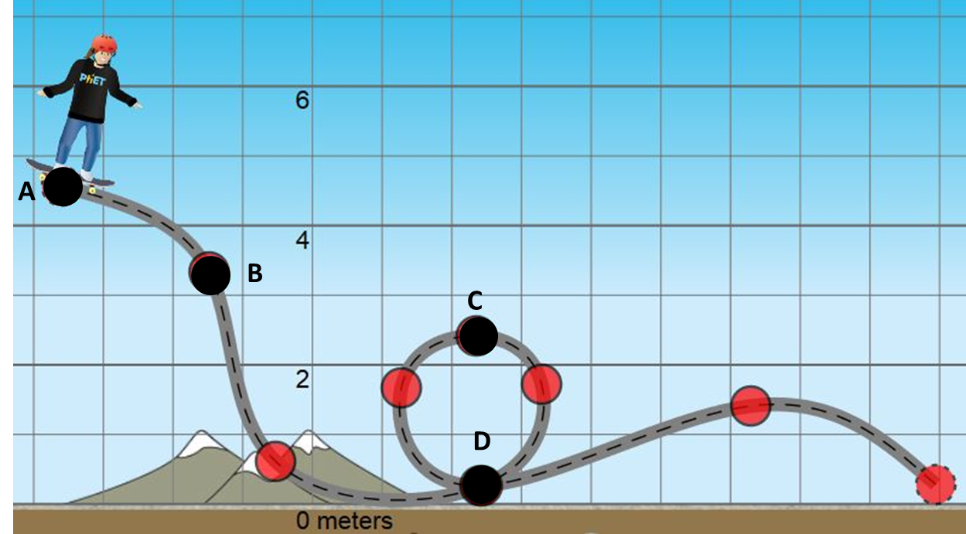
6. Use your experience with the skater system to complete the table below:

Skater’s Position | Describe skater’s speed  (low, med, high  or calculate) | Describe energy forms | Graphical representation of energy (bar graph)
A

B

C

D

