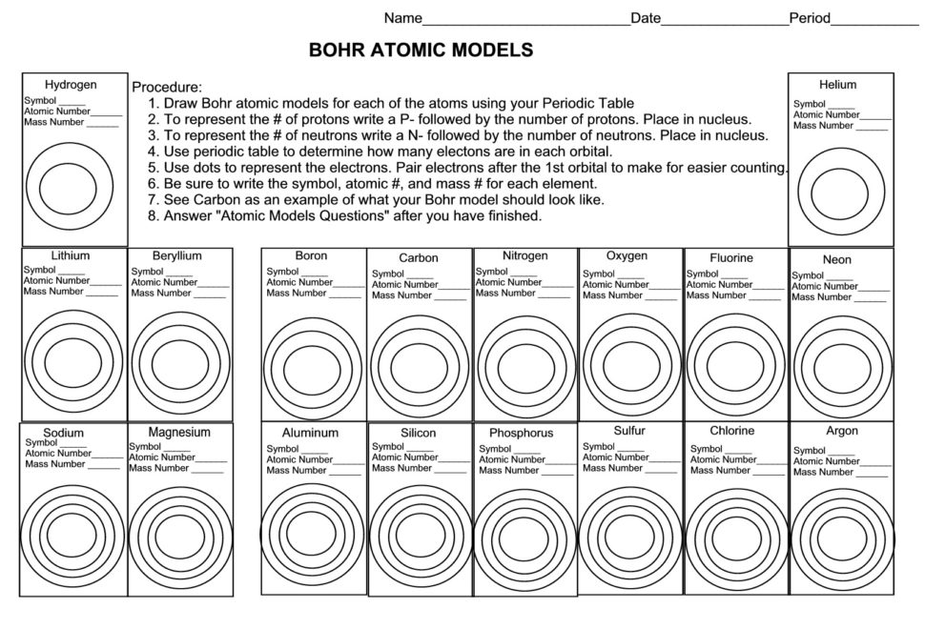
Atomic Model Questions:

- What do you notice about the number of orbitals in elements in a row or period?

- What do you notice about the number of electrons in the outer most orbital looking down a column or family?

- Why do you think atoms of elements in the same family may act the same or have similar qualities?

