**DNA: The Molecule of Heredity**

DNA

* Deoxyribonucleic acid
* Is a type of nucleic acid
* What chromosomes (and genes) are made of
* Made up of repeating nucleotide subunits
* 1 nucleotide looks like:

# Deoxyribose Sugar

Nitrogenous

# Base

4 types: Adenine (A)

Guanine (G)

Cytosine (C)

Thymine (T)

* 2 strands so bases can pair up
  + A binds T only
  + C binds G only

Bases on the inside (Bases fit like puzzle pieces)

Strand 2

Strand 1

Remember

# DNA is like an Oreo

### Phophates + sugars = cookies

#### Bases = cream filling



A

## S

T

## S

## S

G

C

## S

Phosphates + sugars on the outside

Shape is a double helix

* + Double helix: 2 spirals wound around each other
  + Rosalind Franklin took an X-ray photo of DNA
  + James Watson and Francis Crick interpreted the photo and discovered the double helix structure (They won the Nobel Prize)

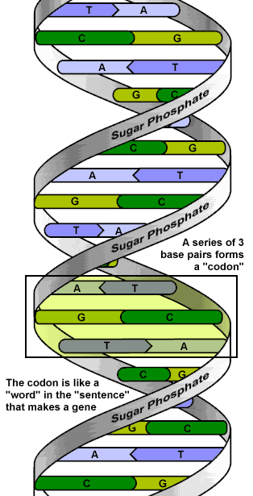

* Genes: stretch of DNA that codes for a trait
  + The code is the order of the bases (letters)
  + Genes are hundreds or thousands of bases long

Hair color gene

## Dimples gene

Eye color gene

## Chargaff’s Rule

* In DNA, the amount of A = the amount of T

the amount of C = the amount of G

DNA is complementary

* Complementary: bases on one strand match up with the bases on the other strand (A-T and G-C)
* Example: Strand 1- ATG GGC CTA

Strand 2- TAC CCG GAT