How Can You Locate The Epicenter of an Earthquake?
Three Types of Waves
Major earthquakes occur when there is rock movement along a fault (crack in the crust). The sudden slippage of huge rock masses sets up shock waves that travel through the earth. The point within the earth where the actual movement takes place is called the focus. As shown in Figure 1, the point on the surface directly above the focus is called the epicenter.
An earthquake epicenter can be located from records made of earthquake waves on devices called seismographs. One type of seismograph is a visible recording machine, shown in Figure 2. A pen draws a pattern of the waves on paper that is attached to a revolving drum. The wave record from a seismograph is known as a seismogram - see Figure 3.
A typical seismogram of an earthquake has three prominent wave patterns. The first waves to arrive are the P-waves (also called "primary" or "push-pull"). They are followed by the S-waves (also called "secondary," "shear," or "shake"). Finally, the L-waves ("long" or "Love") arrive. This investigation contains the seismograms from three different stations for an earthquake. See how accurately you can locate the epicenter of this quake.
Figure 1: Earthquake epicenter and focus

Figure 2: A seismograph
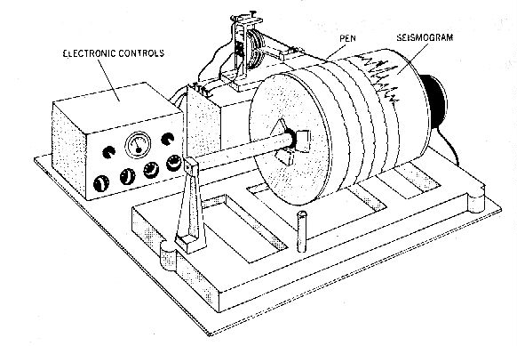
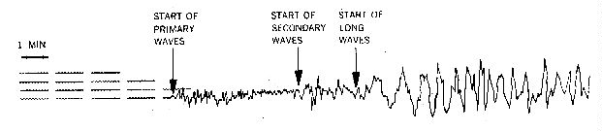
Figure 3: A seismogram

CALCULATING LAG TIMES
Remember that seismographs record three types of earthquake waves which have been described to you in class: 1) P-waves (also called push-pull or compressional waves), 2) S-waves (also called shear or shake waves), and 3) L-waves (also called long or love waves). Each of these waves travel at different velocities (speeds), even though they are generated simultaneously by an earthquake at the focus (point of origin within the crust). Since P-waves travel faster than S-waves do, the seismograph will detect P-waves arriving first, and S-waves will follow. The time difference, as recorded on a clock, between when the P-waves and S-waves arrive is called the lag time. Using the clock time numbers listed in your lab handout, the lag times may be easily calculated.
EXAMPLE
"An earthquake was recorded in San Diego. The seismograph record shows that P-waves first arrived at 10:02-09 PST (read this is "10:02 and 9 seconds, AM, Pacific Standard Time"), and S-waves arrived at 10:03-04 PST. What is the lag time for this earthquake?"
ANSWER
Since S-waves arrived later, you may subtract the time of arrival of the P-waves from it. To do this, you may need to "borrow" extra seconds from the minutes column (much like grade school arithmetic, where fractions may be borrowed from the whole numbers column).
S-wave arrival time = 10:03, 4 seconds => 10:02, 64 seconds
P-wave arrival time = 10:02, 9 seconds => - 10:02, 9 seconds (subtract)
---------------------------------------------------------------------------
ANSWER = 55 seconds

CALCULATING THE DISTANCE OF THE EPICENTER FROM THE RECORDING STATION
This lab exercise will compare and contrast two distinctly different methods for calculating the distance to an epicenter. The first method assumes that earthquake waves travel at constant speed (no speeding up nor slowing down), and uses a mathematical formula to determine velocity, distance, or time, for four earthquake recording stations located in the western United States. The calculated distances for each city are then to be drawn with a drawing compass on the base map (Figure 4). If it can be shown that earthquake waves do not travel at constant speed, then this method is invalid.
The second method assumes that earthquake waves speed up with increasing distance, and the lag time graph (Figure 6) may be used to find either the lag time or the distance to the epicenter. As you will see, the second method works better because it accounts for the increased density of the earth's mantle, outer core, and inner core, which causes earthquake waves to speed up.

To calculated lag time using the arithmetic method, a simplified method using rounded off speed numbers is illustrated below. If you are given information about how fast P-waves and S-waves each travel, a certain lag time will correspond to a certain distance that may be traveled by earthquake waves. In other words, if P-waves travel at 4.00 miles per second, and S-waves travel at 2.50 miles per second, and the lag time is 15 seconds, the distance of the earthquake epicenter will be 100 miles. The method of this calculation is shown below.
Velocity (speed) = V | V_{P-waves} = 4.00 miles  second | V_{S-waves} = 2.50 miles  second
Velocity = Distance  Time | Let distance = 100 miles
Time = Distance  Velocity | Time_{P-waves} = 100 miles  4.00 miles = 25 sec.  second | Time_{S-waves} = 100 miles  2.50 miles =40 sec.  second
Distance = Velocity X Time | Lag Time = 40 - 25 = 15 seconds
How to Use Proportionality
If a lag time of 15 seconds corresponds to 100 miles of distance to the epicenter, how far is the epicenter from another recording station, if that lag time is 30 seconds?
Since the question is "how far," you should use the distance formula, Distance = Velocity X Time. In this case, the "velocity" is the "lag time velocity" or 100 miles/15 seconds.
Distance = 100 miles X 30 seconds = 200 miles
15 sec.

HANDLING MATHEMATICAL CALCULATIONS AND WORD PROBLEMS
Do you remember solving word problems in high school algebra class? If you found these types of problems difficult to solve, it was probably because you didn't know exactly what information you were required to calculate. One of the keys to deciphering word problems is to look for key phrases and apply the appropriate formula:
If the question asks | You are asked to find | Use formula
"How fast..." | speed | distance  time
"How long does it take..." | time | distance  speed
"How far..." | distance | Speed X Time
Understanding & Calculating Lag Time
Compare the relative speeds of 2 vehicles, A and B. Both vehicles leave the same departure point but travel at different speeds. Vehicle A is traveling at 50 miles/hour. Vehicle B is traveling 25 miles/hour. Assuming that neither vehicles slow down nor stop, how long does it take for each to travel 250 miles? Before you blurt out the answer, try using one of the above three formulas. Which is the correct formula to apply here? If you chose the "time" formula, you're right. (Why? The key phrase in the word problem is "how long does it take"). So, if you take the distance, 250 miles; and divide by the speed of each vehicle, you should get:
Vehicle A | Vehicle B
500 miles = 10 hours  50 miles  hour | 500 miles = 20 hours  25 miles  hour
So, the lag time difference between the two vehicles (10 hours - 5 hours) is 5 hours. What would the lag time be if the distance traveled were 500 miles?
Vehicle A would take 10 hours to travel 500 miles, but Vehicle B would take 20 hours. The lag time here is 10 hours. So, the pattern you should note here is "the greater the distance, the longer the lag time."
The same method of calculation may be used for earthquake waves (P-waves and S-waves). However, you must use consistent units. If you are given speed units which are "miles per second," you must not mix them with "miles per hour."
The central assumption for using this methodology for calculating the distance to the earthquake epicenter is that the speed of the earthquake waves does not change with distance. However, in reality, this does not hold true over long distances, especially if the earthquake waves penetrate the denser layers of the earth's interior, which causes earthquake waves to speed up in general.
At least 3 earthquake recording stations are required to find the location of the earthquake epicenter. A single recording station can only calculate distance, but not direction; to cover all possibilities, a complete circle is drawn around that station. If only two earthquake recording stations are used, the circles will overlap at two points. Data from a third recording station will eliminate one of these points. | 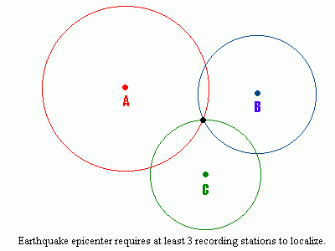

EXERCISES USING THE CONSTANT-SPEED METHOD
1. Four partial records of the same earthquake were recorded at Los Angeles, San Francisco, Salt Lake City, and Albuquerque, shown below. Determine the lag time for each recording station and enter it into the "lag time" column, by subtracting the P-wave arrival time from the S-wave arrival time.
Recording Station | P-wave arrival time | S-wave arrival time | Lag time?
Los Angeles | 11:06-06 PST | 11:06-19 PST | seconds
San Francisco | 11:06-46 PST | 11:07-18 PST | seconds
Salt Lake City | 12:08-06 MST | 12:09-22 MST | seconds
Albuquerque | 12:08-45 MST | 12:10-15 MST | seconds
2. Assuming an average velocity of 3.80 miles/second for the P-waves, and 2.54 miles/second for the S-waves, how long does it take for each type to travel 100 miles? Show how you arrived at your answer.
P-waves took how many seconds? | S-waves took how many seconds?
What is the lag time associated with this distance (100 miles)?
3. Determine the distance from each of the four seismograph stations to the epicenter of the earthquake. Distance may be computed by proportion, using the lag time value to 100 miles that you obtained in Problem 2.
Recording Station | Calculated Distance (miles)?
Los Angeles: | miles
San Francisco: | miles
Albuquerque: | miles
Salt Lake City: | miles
4. On the base map of the western United States (Figure 4), draw circles or arcs with a compass, locating the needle point at each of the four stations, with each radius corresponding to the calculated distance (use the graphic scale on the base map for measurement).
Where is the epicenter located?
Between what cities shown on the map?
Which city is the earthquake epicenter closes to, and how far?
5. Considering the cause of earthquakes discussed during lecture, what major structural feature is probably related to this earthquake?
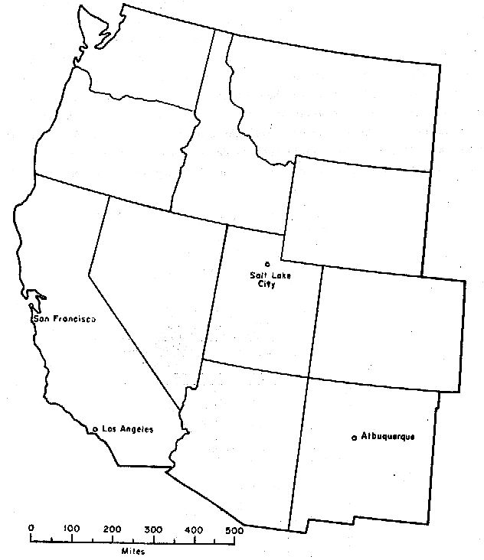
6. The time at which the P-wave arrived at each of the four stations is shown on the seismograph record (Problem 1). But when did the earthquake actually occur? Show how you obtained your answer.

SEISMIC WAVES: A "WINDOW" TO THE EARTH'S INTERIOR
The study of seismic waves is not only useful for helping to predict and prepare for earthquakes - it is also used to help study the properties of the Earth's interior. The deepest drill hole accomplished by man is less than about 3 miles into the Earth's crust. We thus have no direct observation of the thousands of miles of rock below the surface. Seismic waves may be artificially generated with explosives, and then monitored for changes in travel velocities and intensities. Seismic waves increase their speed when traveling through denser material; S-waves cannot travel through liquids. It has been determined by seismologists that the mantle rock is denser than the crust, and the outer core of the Earth is composed of liquid iron, while the still denser inner core is solid.
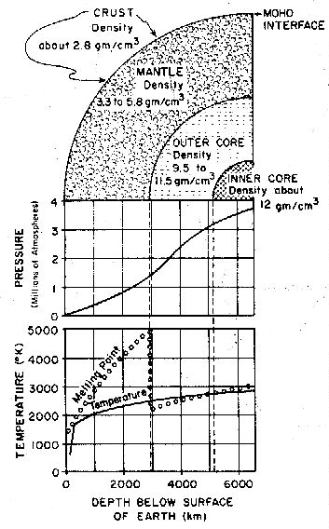
Figure 5: Inferred properties of the Earth's interior

The above graph illustrates that earthquake waves do not travel at a constant velocity over long distances; rather, they speed up as they travel through the denser rock of the earth's interior. In fact, this speeding up is one of the major evidences of the greater density of the mantle rock and the earth's core. Note on the graph that with increasing distances, the travel time required steadily decreases for both S-waves and P-waves. Contrast this method with the previous one, which assumed that the speed of P-waves and S-waves remained constant. The first method would only work for shallow focus earthquakes that traveled through the crust, but not the mantle. To read the above graph, remember that the lag time "fits" only into the shaded (yellow if you have a color version) portion between the two curved lines. Use the edge of a blank sheet of paper to find out how many minutes "fit" between the two curves at a given distance. Or, conversely, given a lag time, you measure out this distance on a sheet of paper by making two marks; "ride" the P-wave curve with one mark until the other mark "falls" on the S-wave curve, while keeping the edge of your paper parallel with the graph markings. Then, read off the edge of your paper to find the distance to the epicenter. Your accuracy for distance should be within the 100 miles, and for lag-time, within 0.1 minute.

