The Earth’s Interior

Diagram:

How do we know what we know:

- Direct Sampling:
  - Drilling: up to 10km
  - Volcanoes bring up material from interior

- Indirect measurements
  - Using S and P waves to find out data about below the mantle

The layers:

The Earth’s layers are arranged according to their density:

During its formation the Earth was a ball of viscous material, but over time denser metals like lead and nickel sank to the middle of the Earth.

Lighter elements like oxygen and silicon floated to the surface to form the crust

The middle region is a mixture of both metals and non-metals.

The crust, core, and mantle are different compositionally. The lithosphere and asthenosphere, outer core and inner core are different structurally.

The change P and S waves thought the Earth give us data on the sections:

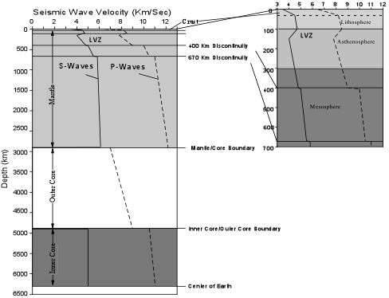

- Speeds increase from mantle to asthenosphere to crust as density increases.
- S-waves stop in the inner liquid core.

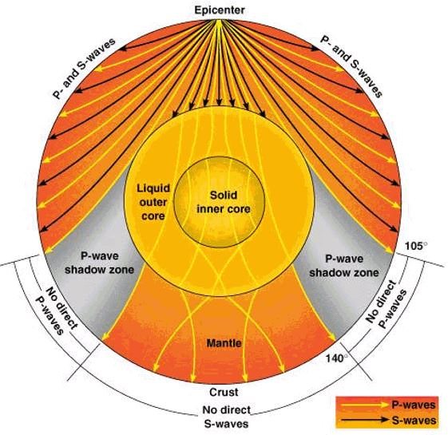

The Earth’s strong magnetic field suggests the core is full of swirling charged particles.
- The same is true for gas giants and the sun
- Other terrestrial planets have no magnetic poles so must have solid cores

Earth’s gravity is strong for a planet its size, suggesting the core is very heavy and must consist of mainly metals like iron

