**Family Trees**

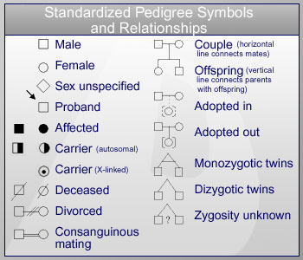

A **genogram** is a picture or display showing a person's [family relationships](https://en.wikipedia.org/wiki/Family_relationships) or medical history

The standard symbols used are shown at the right, but we will only use some of them in our work today.

**Symbols we will use:**

Female Male

Affected female Affected male

Carrier female

**Autosomal Dominant**

Gene is not on the X chromosome

Males and females are equally likely to have the trait.

Examples: Marfan syndrome, Huntington’s disease, achondroplastic dwarfism

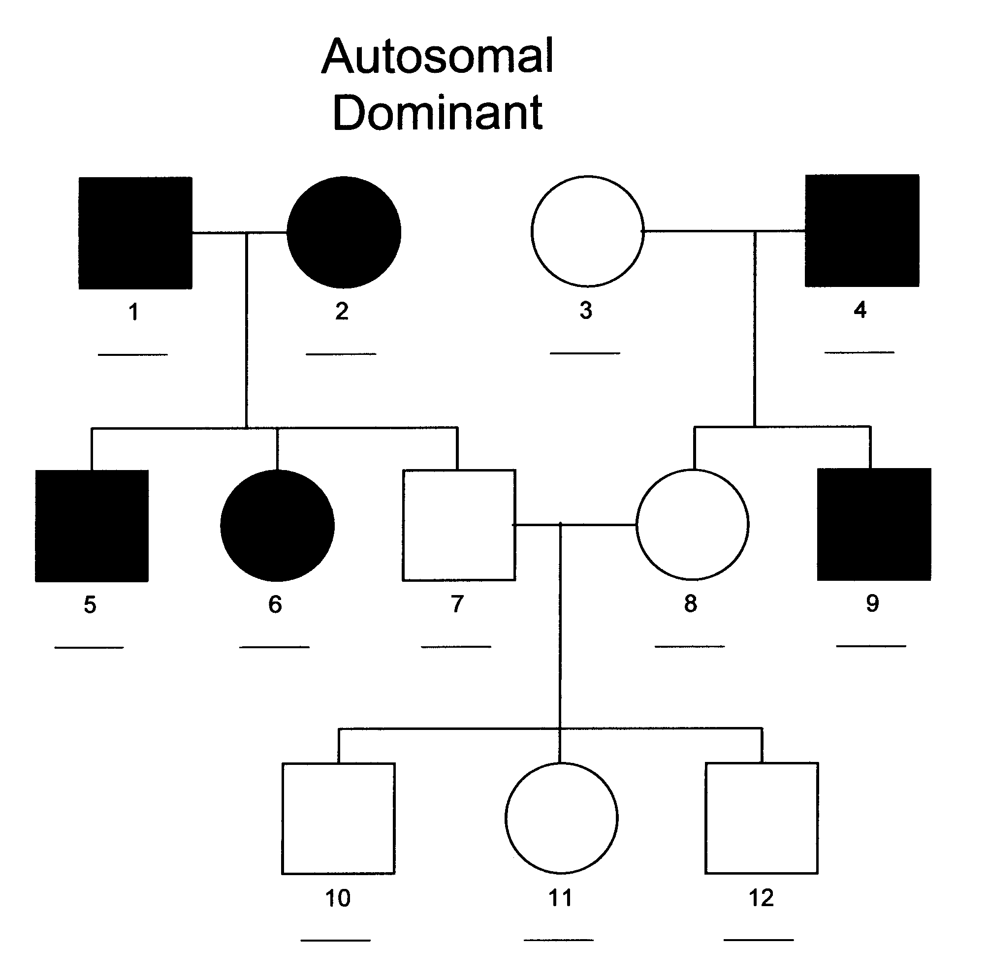Genotypes

1.

2.

3.

4.

5.

6.

7.

8.

9.

10.

11.

12.

**Autosomal Recessive**

Gene is not on the X chromosome

Males and females are equally likely to have the trait.

If both parents express the trait, then **all** their offspring should also express the trait

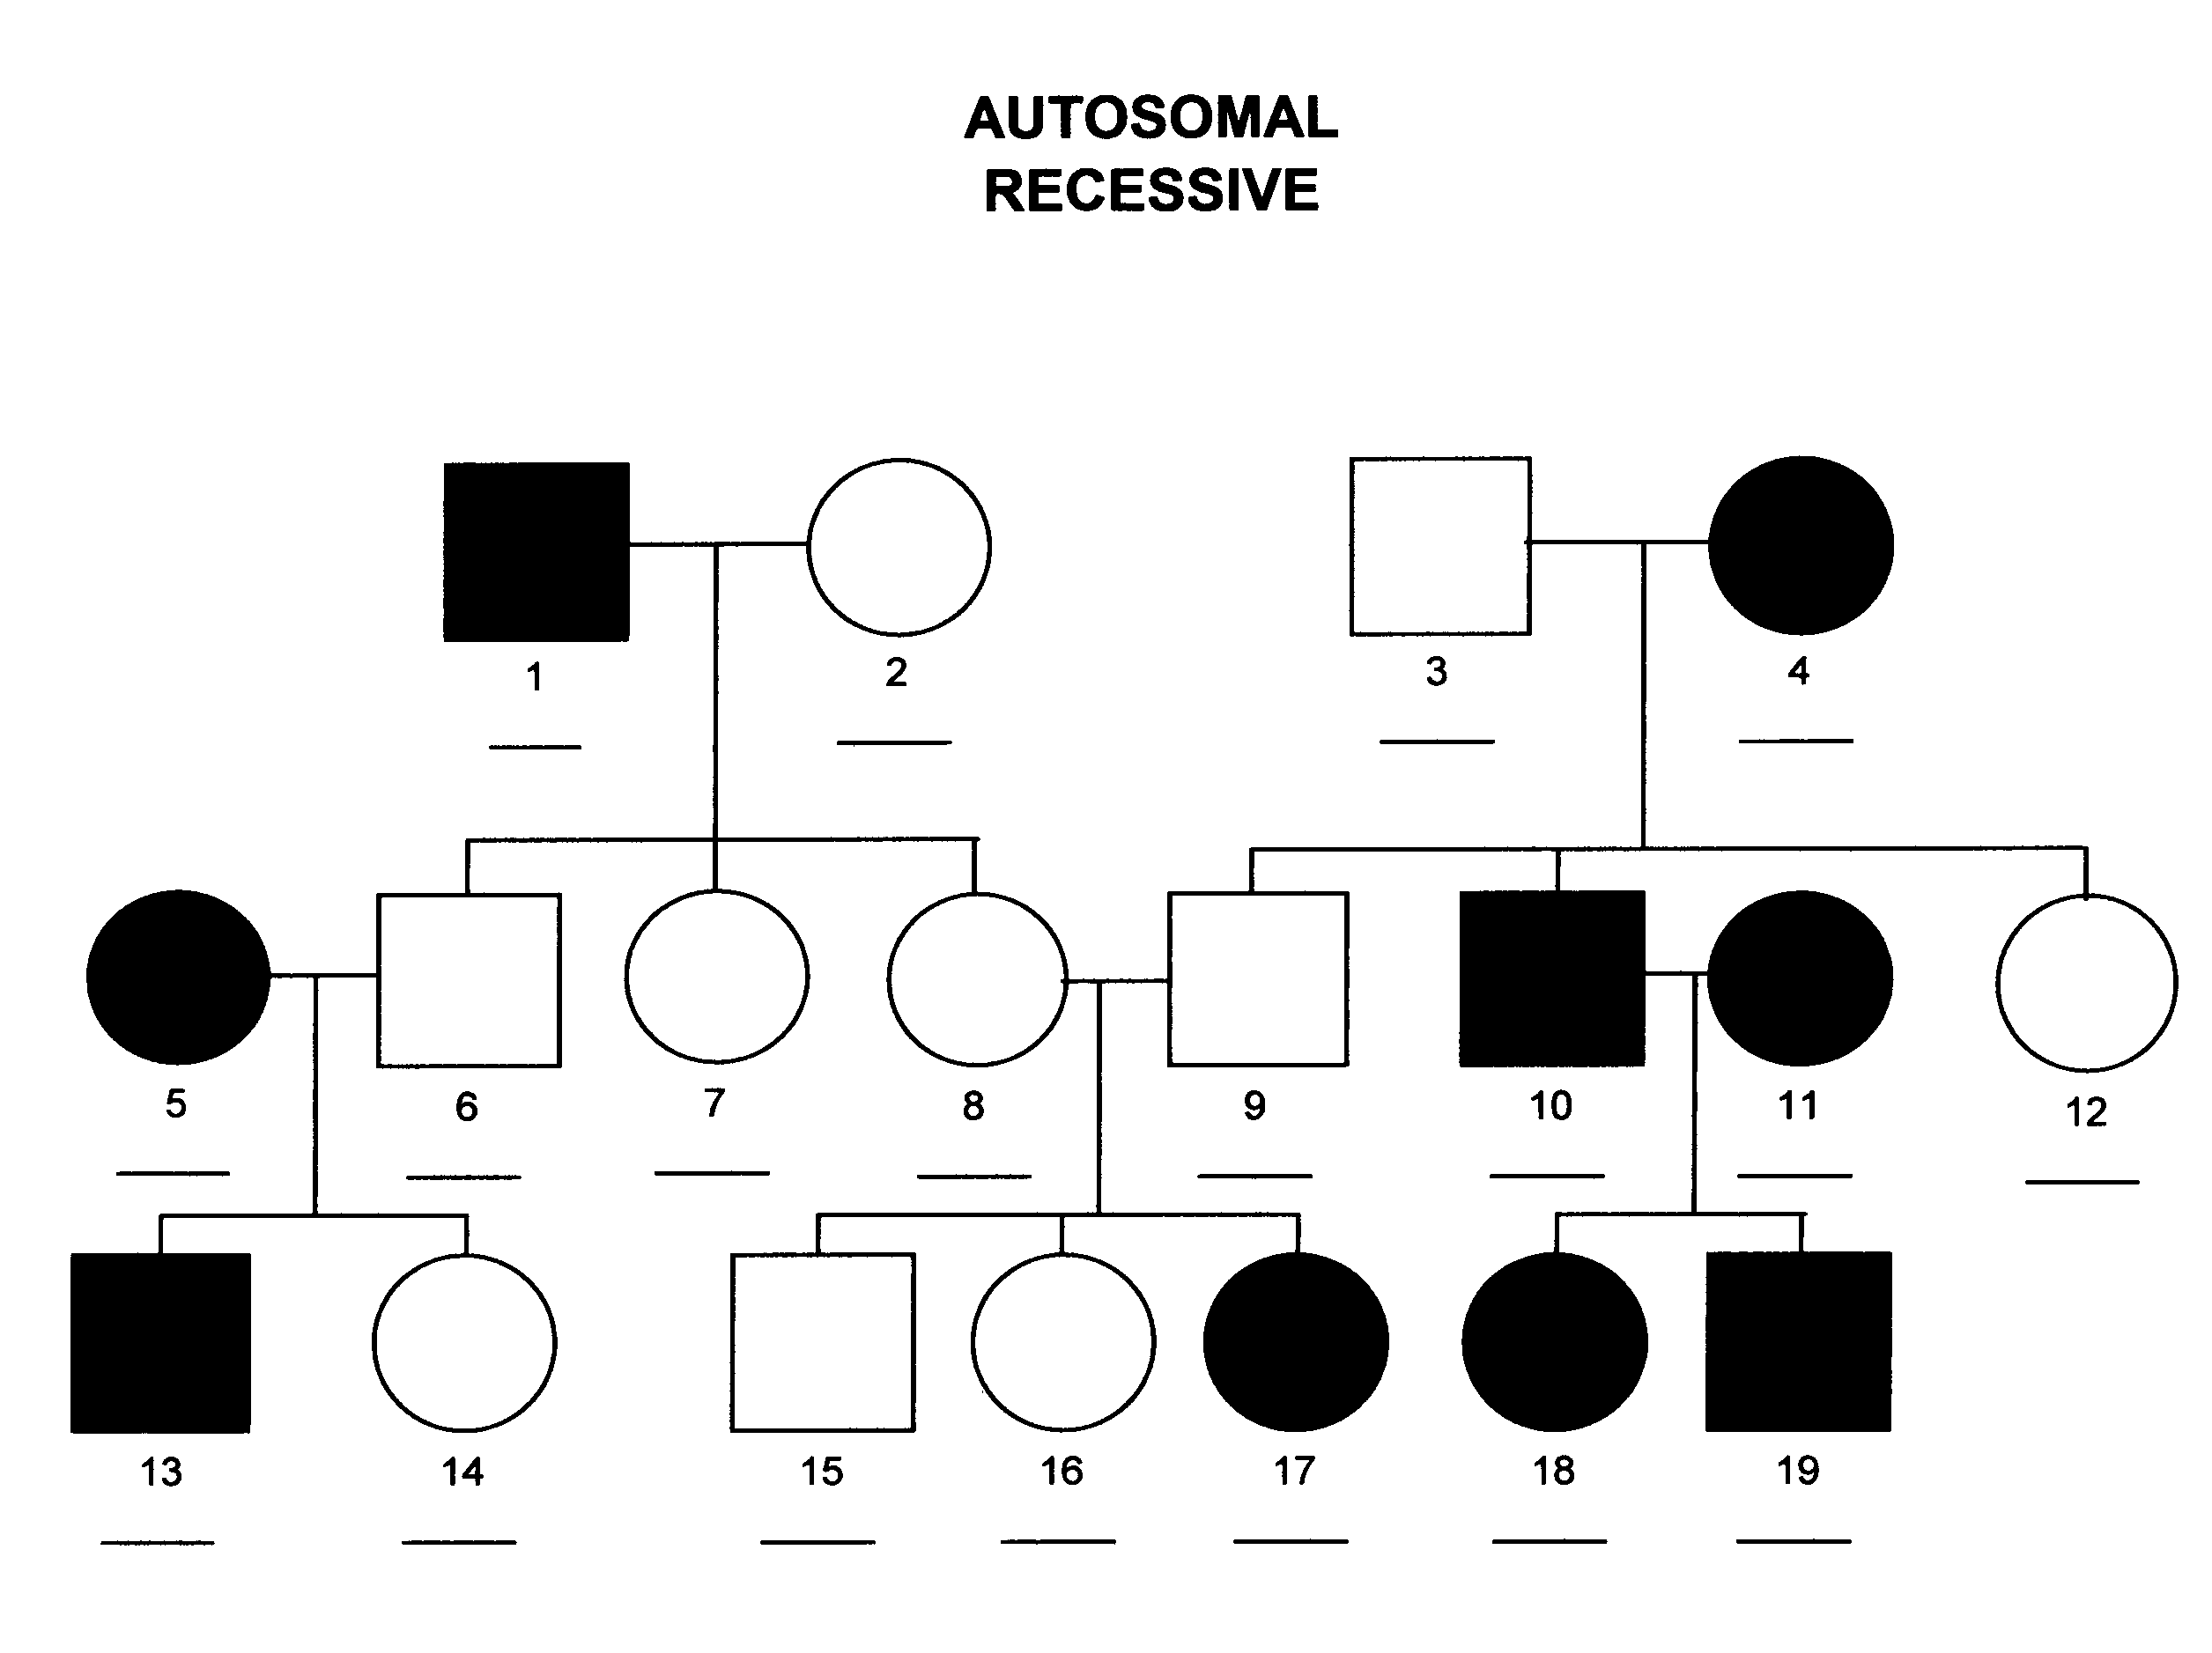 Examples: cystic fibrosis, albinism

Genotypes

1. 11.

2. 12.

3. 13.

4. 14.

5. 15.

6. 16.

7. 17.

8. 18.

9. 19.

10.

**Sex-linked Recessive**

The trait is more common in males than in females.

If a mother has the trait, all of her sons should also have it.

There is no male to male transmission.

Examples: colour-blindness, hemophilia

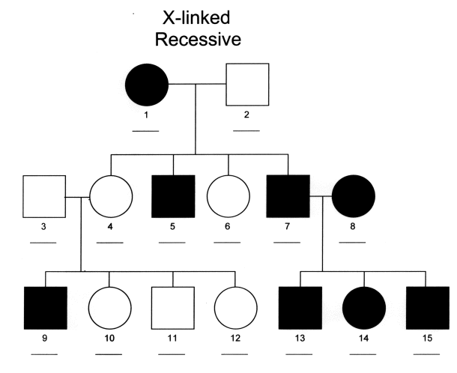

Genotypes

1. 9.

2. 10.

3. 11.

4. 12.

5. 13.

6. 14.

7. 15.

8.

Below is a blank family tree. Assume some members of this tree are affected by a disease. The individuals in the following boxes show this trait phenotypically: 1, 3, 5, 11, 13, 19. Shade in these boxes.

a) Look back at the trees you did on the first two pages (autosomal dominant and X-linked recessive). What type of inheritance pattern does this represent (circle one):

autosomal dominant OR x-linked recessive

b) Write the genotypes for all individuals in the boxes.



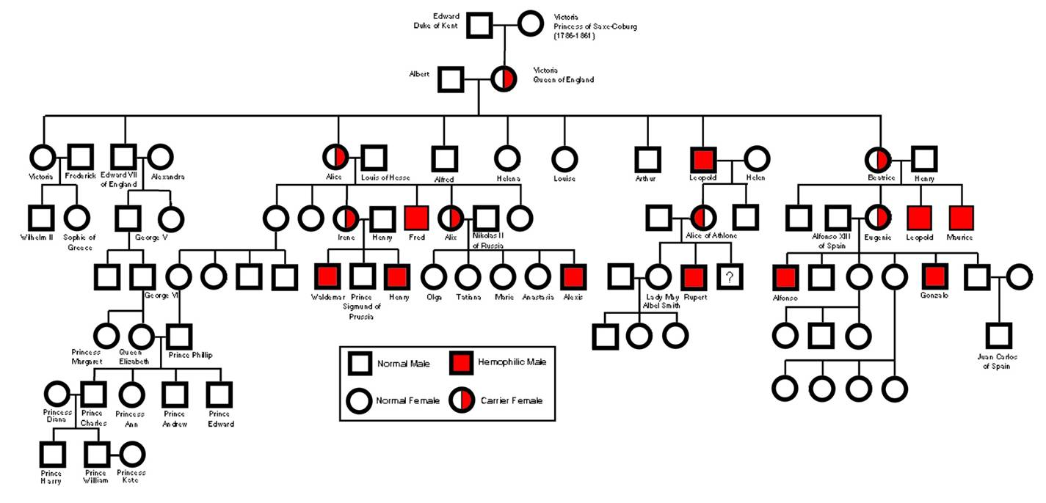

Hemophilia is a sex-linked trait. This blood disease is evident in some descendants of Queen Victoria and Prince Albert of England. Below is their family tree.

1. The present Royal Family is descended from George VI. Is it possible for Princes William or Harry to be affected by this trait?

2. Suppose Prince Waldemar of Prussia married a Princess who was heterozygous for hemophilia. Could any of their sons or daughters have turned out not to have hemophilia? Show your work:

3. There are several known carriers of hemophilia on this tree. Shade them in properly.