Name: ___________________________ Physics 11
Worksheet 2.1
Vectors

Add the following vectors by drawing them and drawing the resultant. In each case, show two different ways that the vectors can be added.

5 m/s left + 7 m/s up

20 m/s² south + 10 m/s² east

4 N up + 3 N down + 3 N left + 1 N right

A child starts at the dot below, crawls 4 m East, then 4 m South, then 1m West, then 8 m North, then 7 m West.
- Below, draw the child’s displacement for each portion of his/her journey.
- Draw the child’s total displacement (the resultant) for the whole journey.
- Calculate the distance the child traveled.

N
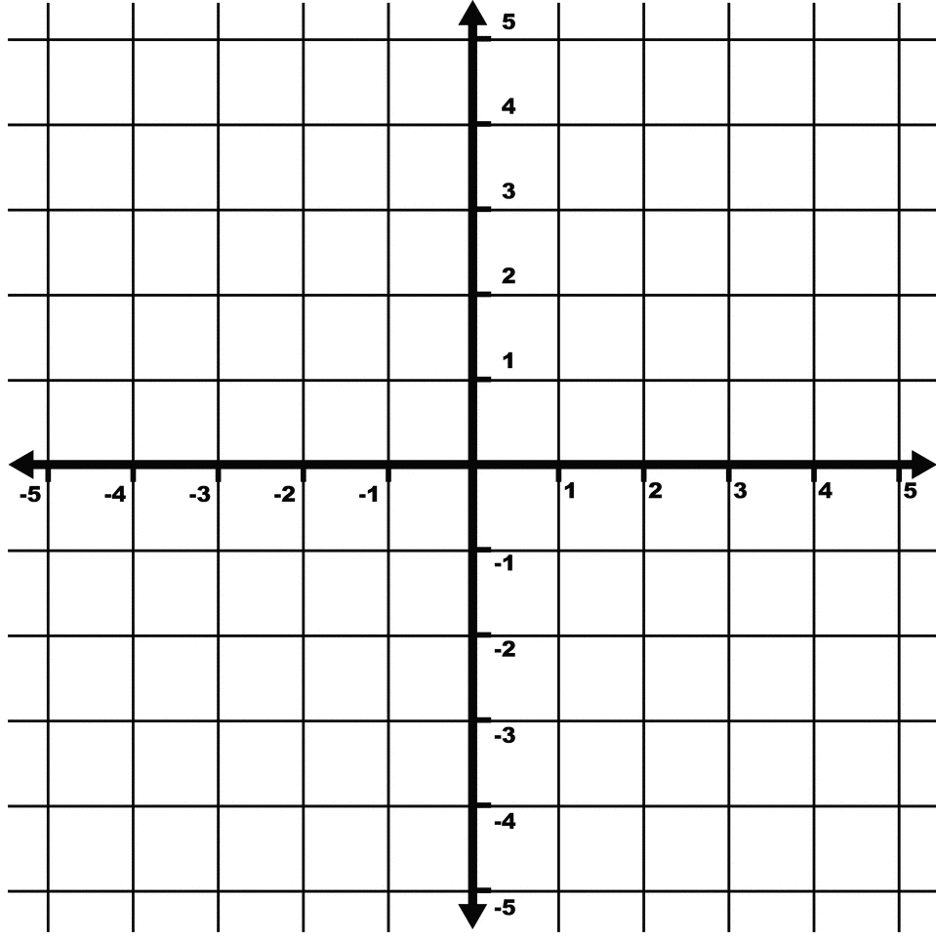
W
E
S

